**Subhan Bin Yousaf**

**Section B**

**481281**

**FOP Lab Manual 8**

**Lab Tasks**

**Task 1 :**

#include <iostream>

using namespace std;

int main(){

int arr[10];

int sum,avg=0;

for(int i=0;i<10;++i){

cout<<"enter number for spot "<<(i+1)<<": ";

cin>>arr[i];

}

cout<<"Entered numbers are: ";

for (int i=0;i<10;++i){

cout<<arr[i]<<" ";

sum=sum+arr[i];

}

avg=sum/10;

cout<<endl;

cout<<"the average of the numbers in the array is: "<<avg;

}

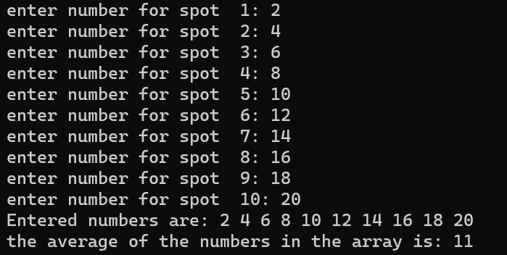

**Task 2 :**

#include <iostream>

using namespace std;

int main(){

int arr[5];

int a,d;

for(int i=0;i<5;++i){

cout<<"enter number "<<(i+1)<<": ";

cin>>arr[i];

}

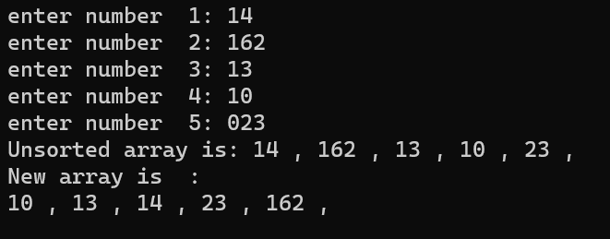 cout<<"Unsorted array is: ";

for (int i=0;i<5;++i){

cout<<arr[i]<<" , ";

}

cout<<endl;

for (int i=0;i<4;i++){

for (int c=0;c<5-i-1;c++){

if (arr[c]>arr[c+1]){

d = arr[c];

arr[c] = arr[c+1];

arr[c+1] = d;

}

}

}

cout<<"New array is : " <<endl;

for (a=0;a<5;a++){

cout<<arr[a]<<" , ";

}

cout<<endl;

}

**Task 3 :**

#include <iostream>

using namespace std;

int main(){

int arr[5];

int a,d;

for(int i=0;i<5;++i){

cout<<"enter number "<<(i+1)<<": ";

cin>>arr[i];

}

cout<<"Unsorted array is: ";

for (int i=0;i<5;++i){

cout<<arr[i]<<" , ";

}

cout<<endl;

int temp;

int m;

for (int i=0; i<4;++i){

m=i;

for (int j=i+1;j<5;++j){

if (arr[j]<arr[m]){

m=j;

}

}

temp=arr[m];

arr[m]=arr[i];

arr[i]=temp;

}

cout<<endl<<endl;

cout<<"Sorted array : ";

for(int i=0;i<5;++i){

cout<<arr[i]<<" ";

}

cout<<endl;

}

